**2.3 – Linear Functions and Slope-Intercept Form**

**Slope – Intercept Form:** **y = mx + b**

m =

$$slope=$$

b =

*Examples:*

*Write an equation of the line shown:*

*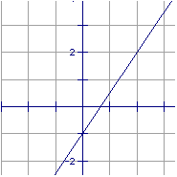m=*

*b=*

*Write an equation of the line with the given slope and y-intercept.*

**Graphing Equations in Slope-Intercept Form;**

1. Write the equation in slope-intercept form by solving for y
2. Find and plot the y-intercept (0, b)
3. Find the slope (m) and use it to plot a second point
4. Draw a line through the two points

*Examples:*

*Find the slope and y-intercept of the line*

*y = -2x – 7 2x – 3y = 18*

*Graph the following linear equations:*

y = 2x + 3 y = 7